Create a simple cloud software application for Property Buying & Rental process (In Chennai city) using any Cloud Service Provider to demonstrate SaaS include the necessary fields such as Buy, Rent, commercial, Rental Agreement, Rental Agreement, Area, place, Range, property value etc.

AIM:
Create a simple cloud software application for Property Buying & Rental process (In Chennai city) using any Cloud Service Provider

PROCEDURE:
STEP 1:
Open browser and get into zoho ceator. Then sign in and click “Create application”. Below given screenshot will appear, hear type the application name of your Aim.

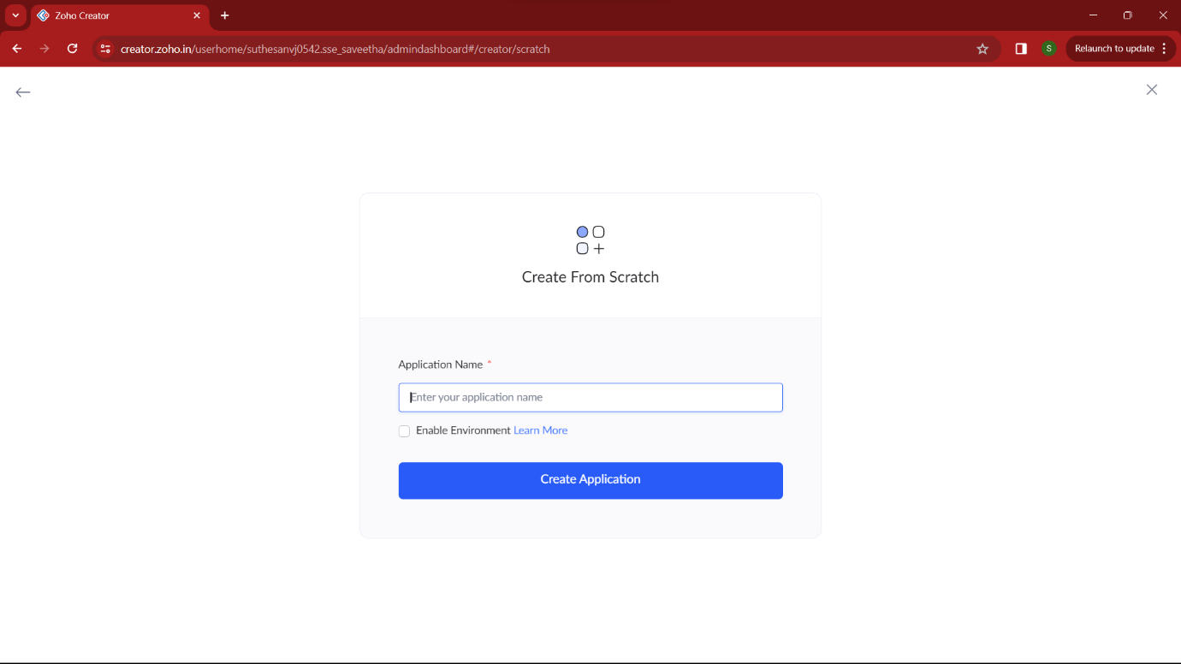

STEP 2:
Then select “start from scratch” option and select the proper component from the 4 components listed. For my application I just selected “forms” for the login credentials.
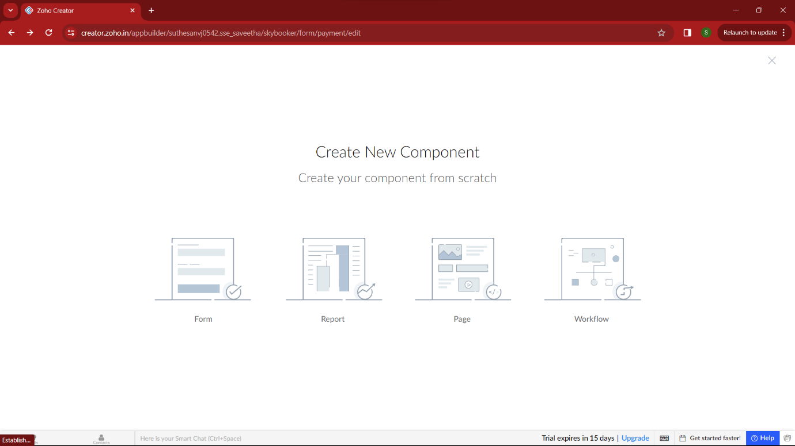

STEP 3:
In forms, below given options will be given. From here we can get sample templates of our requirements, otherwise we can import already saved schema for our application. I just selected “ from scratch” option for my application.
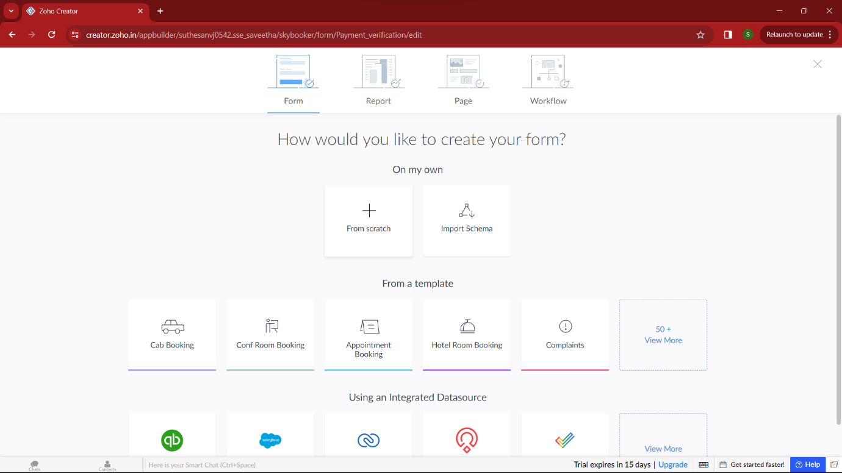

STEP 4:
Then provide an appropriate name for our application in the name form which shown below. I gave “BuyNest” for my “property buying and rental process”

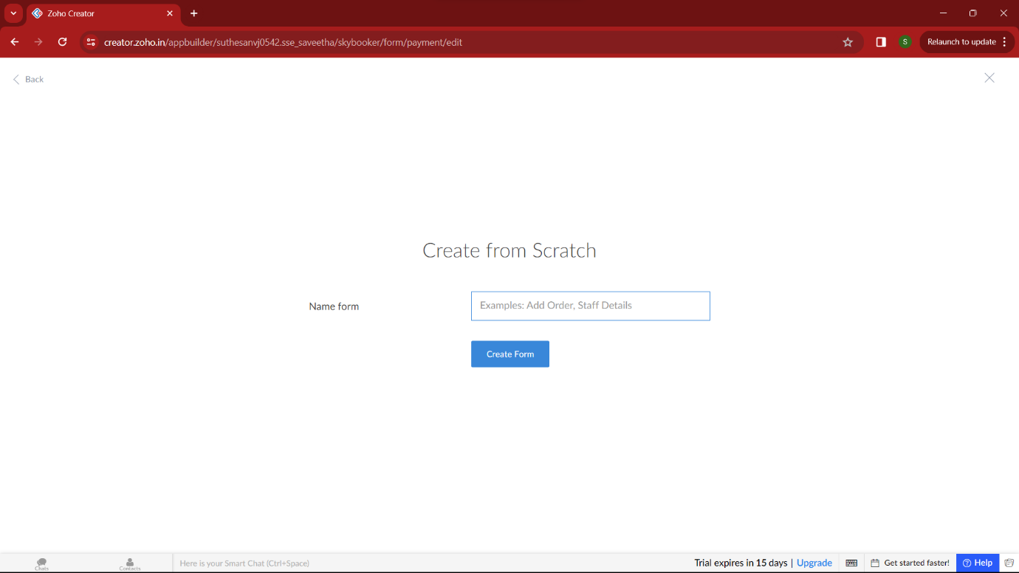

STEP 5:
by clicking “+” symbol shown in the picture given below, we can add number of forms in our application. Firstly I placed login form in my application with the essential credent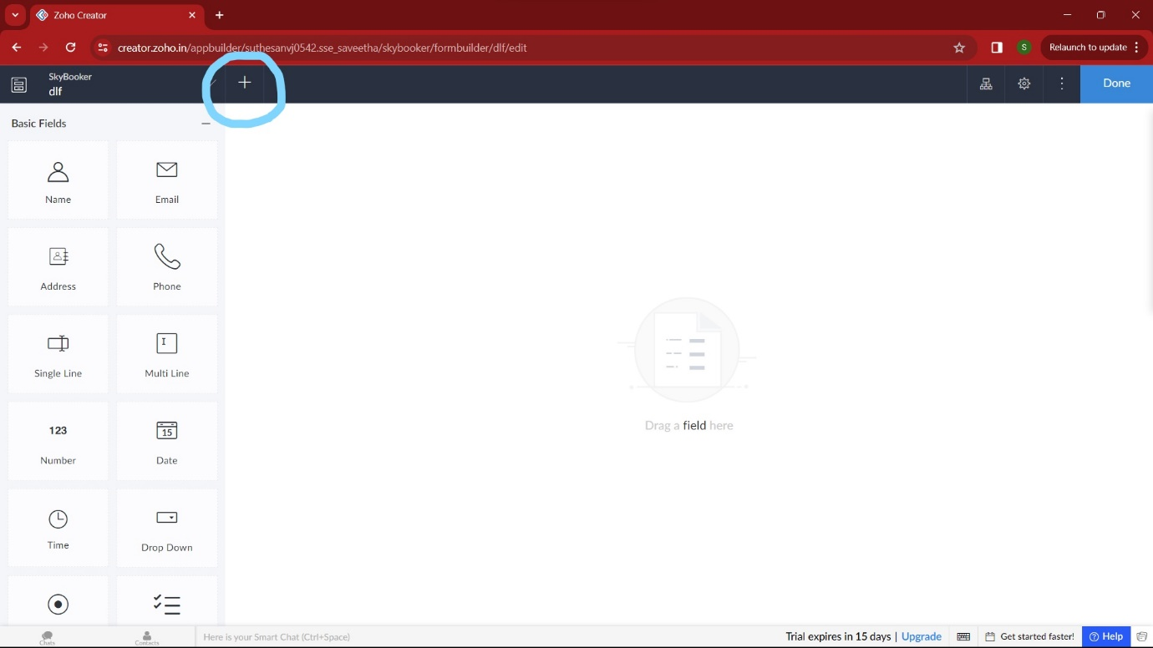

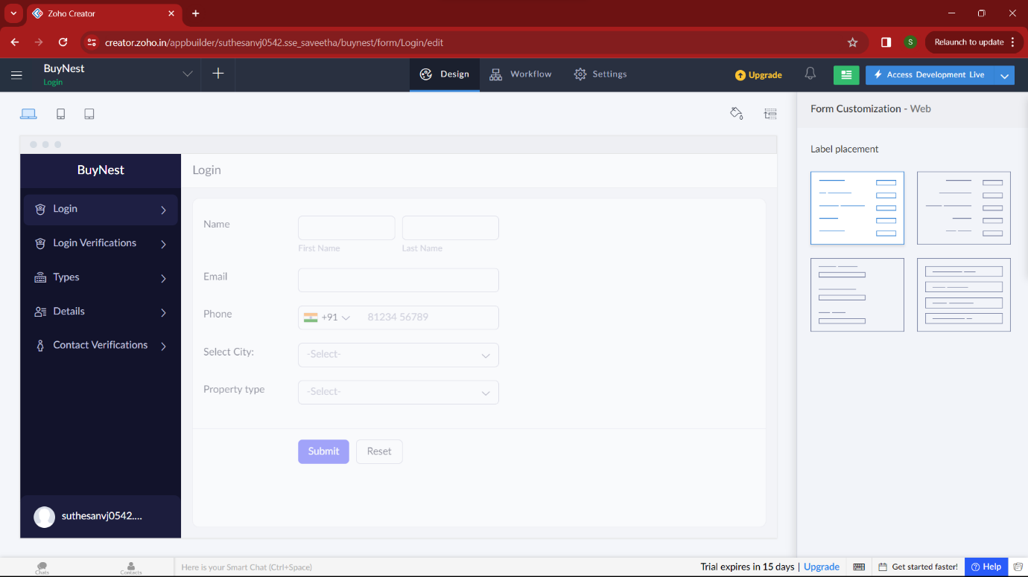

STEP 6:
Then I added another form namely login verification. It verifies user by getting the correct OTP from user, if wrong it takes the user again to the login section/ allow to resend the OTP.
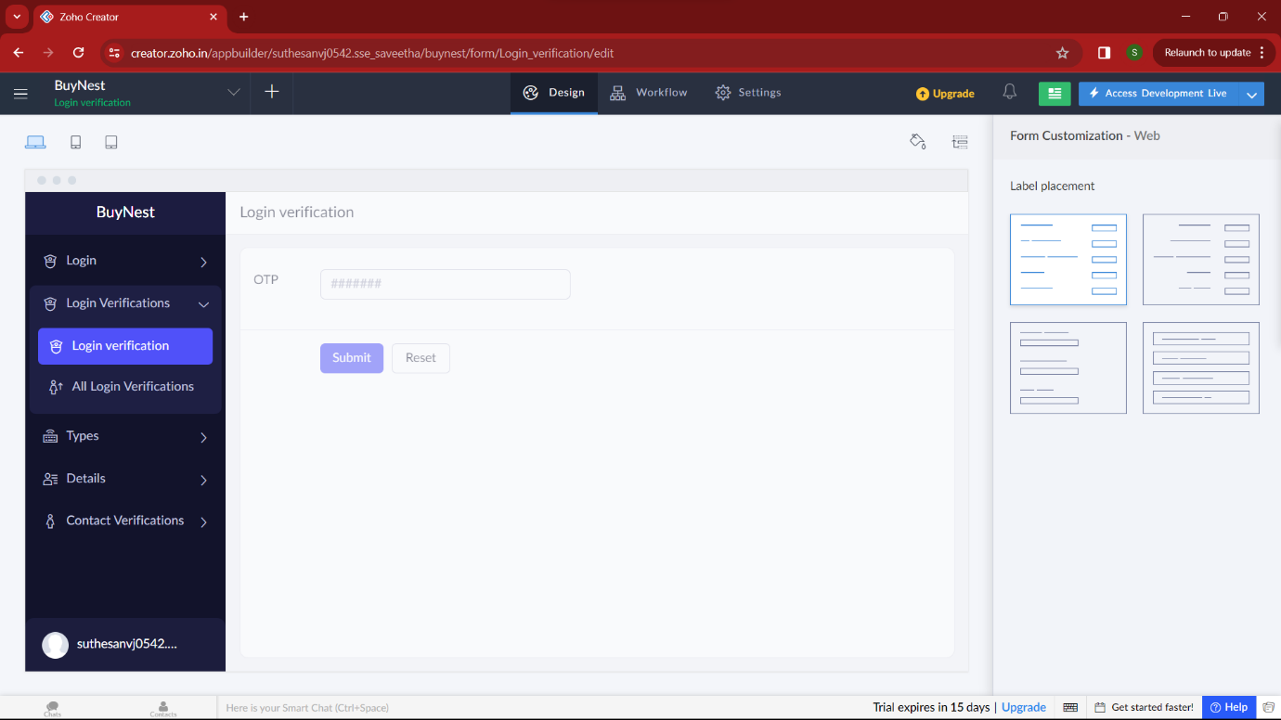

STEP 7:
Then I added another form namely “Type” which gets all the house/plots/apartments details from the user like select city, landmarks, Type, BHK type, Availability, etc. By these our application can find the house/plots by these required conditions.
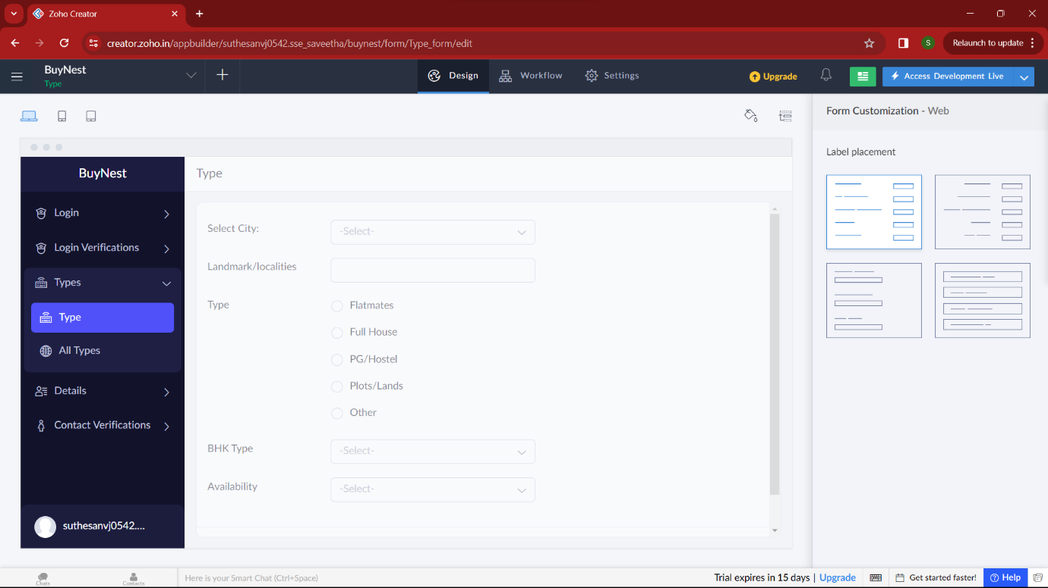

STEP 8:
Then in the next form I added “details” of the selected thing. Here user can get the required data of selected house/apartment which is given below. He can also get the owner contact detail also.
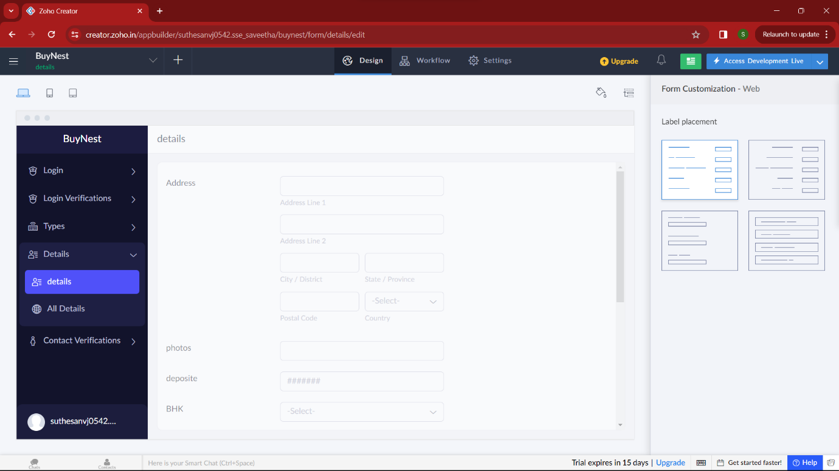

STEP 9:
In this form , the user will provide the correct OTP for accessing the owner contact details, because of the privacy. by these steps an user/customer can buy/rent any property
